**LAB NO. 1**

**Course Name: Enterprise Distributed Systems**

**Course Code: CMPE 273**

**Due date: 15th October 2017**

**Name of the student: Anshit Sobti**

**Student ID: 012364456**

**INTRODUCTION:**

**Goals:**

Our main goal in this lab is to create two applications (client and server sides of both):

**First application** is a calculator that can perform basic functionalities ( + , - , * , / ) on the numbers entered by the useron the client side and display the results.

The application is then tested via JMeter where a single user invokes 1000 random tasks, which in the next test are increased to 5000 tasks and then finally 100 concurrent users with 1000 tasks each is tested.

Graphs are to be drawn and average time is to be calculated for each scenario and comparisons are to be made.

**Second application** is a prototype of Dropbox which allows you to perform various operations on it such as signing up the user, signing out, uploading files and to maintain files in a user’s account etecetra.

The application on the server side is to be tested by Jmeter which tests it for 100, 200, 300, 400 and 500 concurrent users with and without connection pooling and graphs need to be drawn for the same.

**Purpose:**

The main purpose of both these applications is to deal with all kinds of exception and provide the user with a stable system where connection pooling in the Dropbox can allow more than one user to submit there request at the same time and these requests are queued. The uninterrupted running of the system is the main purpose of the system.

**SYSTEM DESIGN:**

1. **CALCULATOR**

**Architectural Design-**

It has one ‘ejs’ file which takes care of the view of the applicationand is named index.ejs.

Other than the view, there are 2 ‘js’ files named app.js and Calculate.js.

Calculate.js takes care of the basic operations of the calculator and app.js is the entry point of the application which sets the routes of the application and connects with the ejs file.

**Logical Design-**

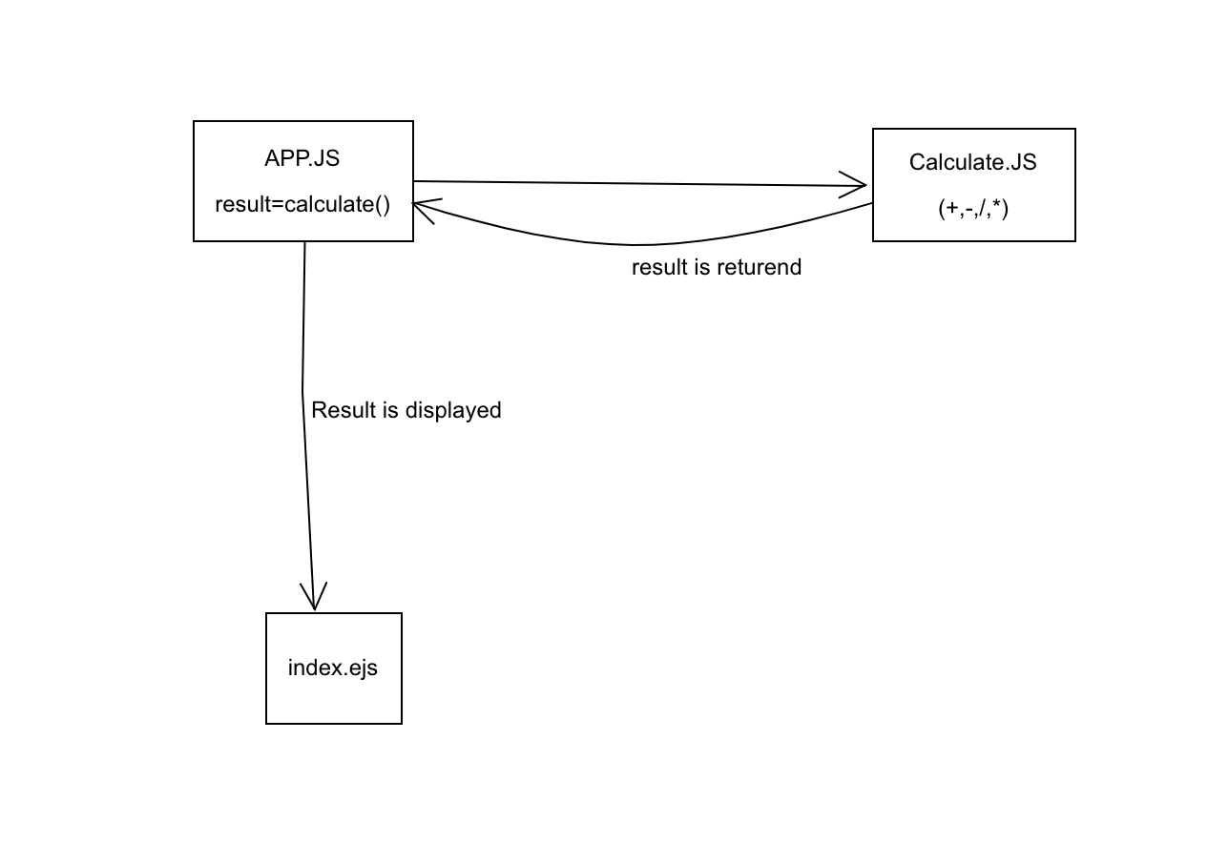

**Physical Design-**

The users enter the numbers they want to use and perform certain operations on them by choosing that option from the given buttons and the result is displayed in the field named as Result.

1. **DROPBOX**

**Architectural Design-**

App.js is the entry point of this application where all the require operations, get and post commands are used. Home.js consists of most of the functions where the code of functionalities are written such as aftersignup and aftersignin.

Mysql.js takes care of the connection of database to the application and also forms a connection pool.

Then there are views for each of the operation such as successlogin, successsignup, failedlogin etcetra.

**Logical Design-**

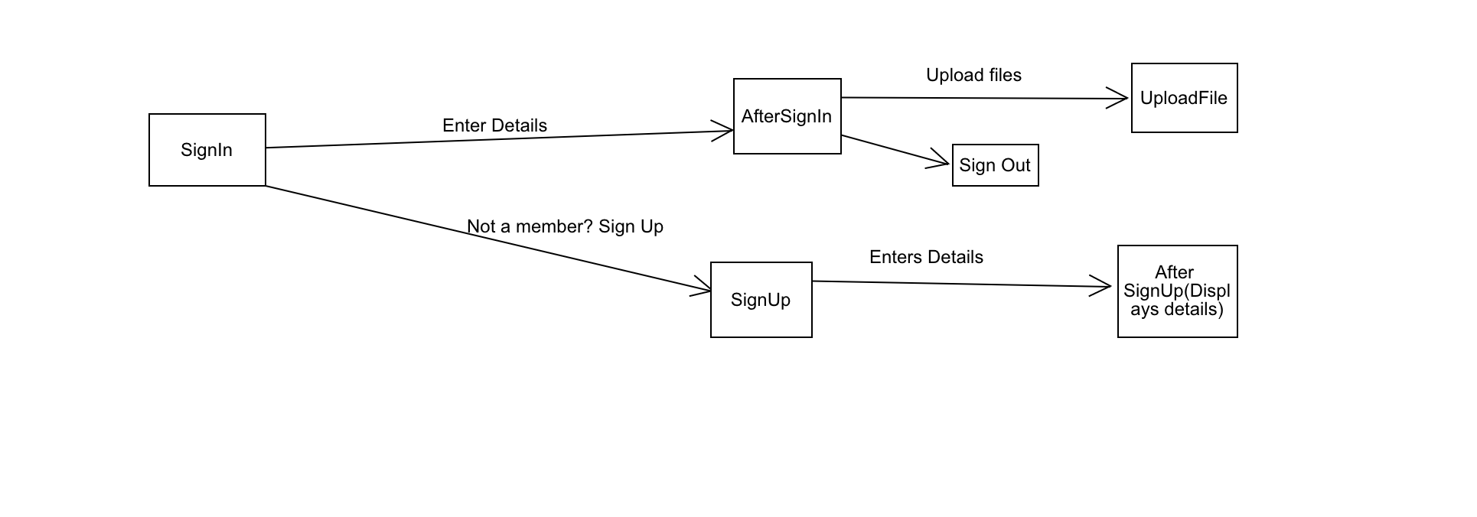

**Physical Design-**

The users can login if they already have an account or can signup otherwise. After creating an account, when they login they will be redirected to the homepage where they can upload files which will be saved in the database corresponding to their user id and later on when they login, the uploaded files will be listed on their homepage.

**Question**:

Explain the encryption algorithm used in the application. Mention different encryption algorithms available and the reason for your selection of the algorithm used.

**Answer**:

The password hashing function known as bcrypt is used in this application which depends on the “Eksblowfish” key setup algorithm which is as follows:

EksBlowfishSetup(*cost*, *salt*, *key*)

*state*

{\displaystyle \gets }

InitState()

*state*

{\displaystyle \gets }

ExpandKey(*state*, *salt*, *key*)

**repeat** (2*cost*)

*state*

{\displaystyle \gets }

ExpandKey(state, 0, key)

*state*

{\displaystyle \gets }

ExpandKey(state, 0, salt)

**return** *state*

Bcrypt algorithm (given below) uses Eksblowfish() function and ExpandKey() function:

bcrypt(*cost*, *salt*, *input*)

*state*

{\displaystyle \gets }

EksBlowfishSetup(*cost*, *salt*, *input*)

*ctext*

{\displaystyle \gets }

"OrpheanBeholderScryDoubt" //three 64-bit blocks

**repeat** (64)

*ctext*

{\displaystyle \gets }

EncryptECB(*state*, *ctext*) //encrypt using standard Blowfish in ECB mode

**return** Concatenate(*cost*, *salt*, *ctext*)

* Bcrypt function is used in my application using following statement and then the saltRounds are defined to a number:

var bcrypt **=** require('bcrypt');

const saltRounds **=** 10;

SaltRounds generate the same number of rounds of salt values as defined by the developer. Salt is a random value that is added to the password and then the hashing function is applied to the value of (salt+password) to generate a hashed password.

* To hash a password following line of code is used:

bcrypt.hash(myPlaintextPassword, saltRounds, function(err, hash) {

*// Store hash in your password DB.*

});

* To compare with the entered password of the user the following function is used:

bcrypt.compare(myPlaintextPassword, hash, function(err, res) {

*// res == true*

});

* Bcrypt is based on blowfish ciphers which is quite safe and no relevant cryptanalysis of it has been found till date. It does a block encryption on a part and then uses that result to replace some other subkeys and this goes on until all keys have been traversed.

Some of the other algorithms that could be used for encryption are:

* Password Based Key Derivation Function-2 (PBKDF2)
* Secure Hash Algorithm 2 (SHA-2)
* AES 256 bit encryption

The less speedy the password hashing function, the better it is for the security. Therefore, Bcrypt is in some ways better than PBKDF2 as it aims to be as slow which makes it harder for the attacker. Bcrypt function heavily relies on a table which is constantly altered throughout the execution. This is very slow on a GPU and hence the attacker has a hard time attacking this and at the same time it is very fast on a PC.

Bcrypt when compared to SHA-256 uses a modified key setup algorithm which is called key strengthening which means the attacker now needs more time to decrypt and hence makes it more secure.

AES 256 bit encryption has also not undergone cryptanalysis like brcypt but brycpt (Blowfish) uses vastly large number of key possibilities but is not acclaimed as AES.

**RESULTS OF APPLICATIONS: (SCREEN CAPTURES)**

1. **CALCULATOR-**

This is the client side of the calculator, where the user can put numbers and choose operations to be performed upon those numbers and the result is printed.

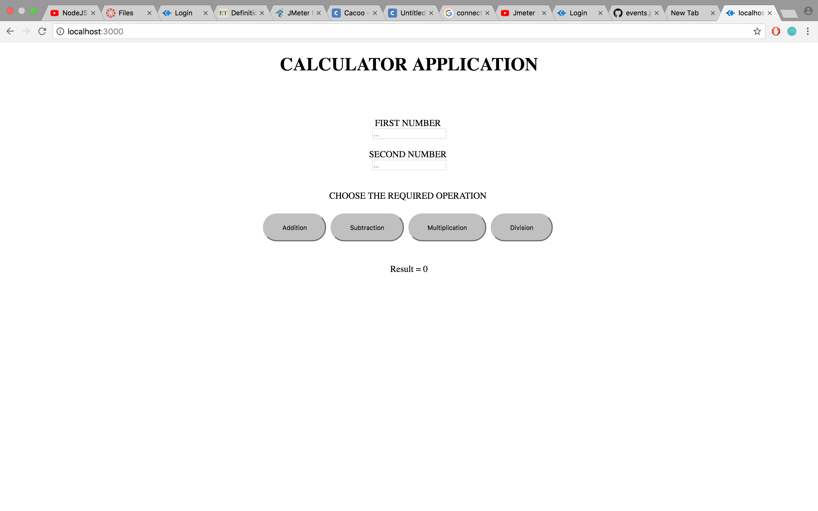

The screenshot given below shows the operation of 18/3 and the result being visible as 6.

(Contd…)

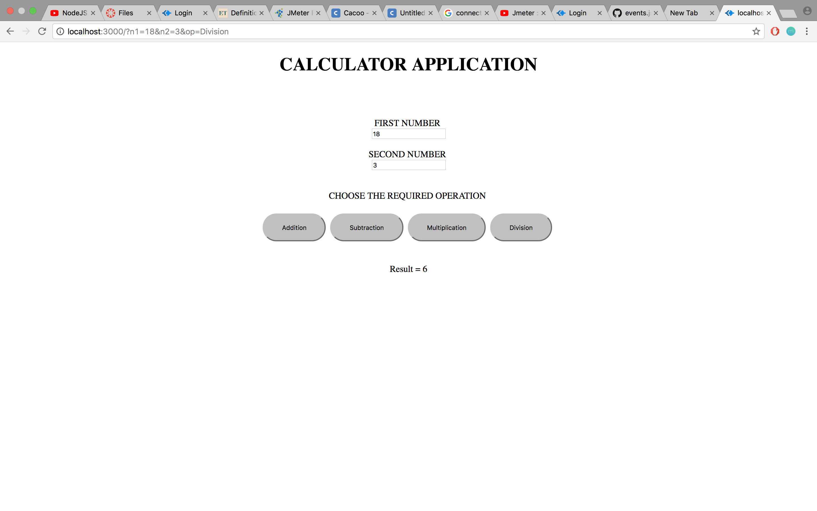

Following are the graphs made in Jmeter after testing it for 3 scenarios in each operation

**ADDITION: (When 1000 calls are made**) 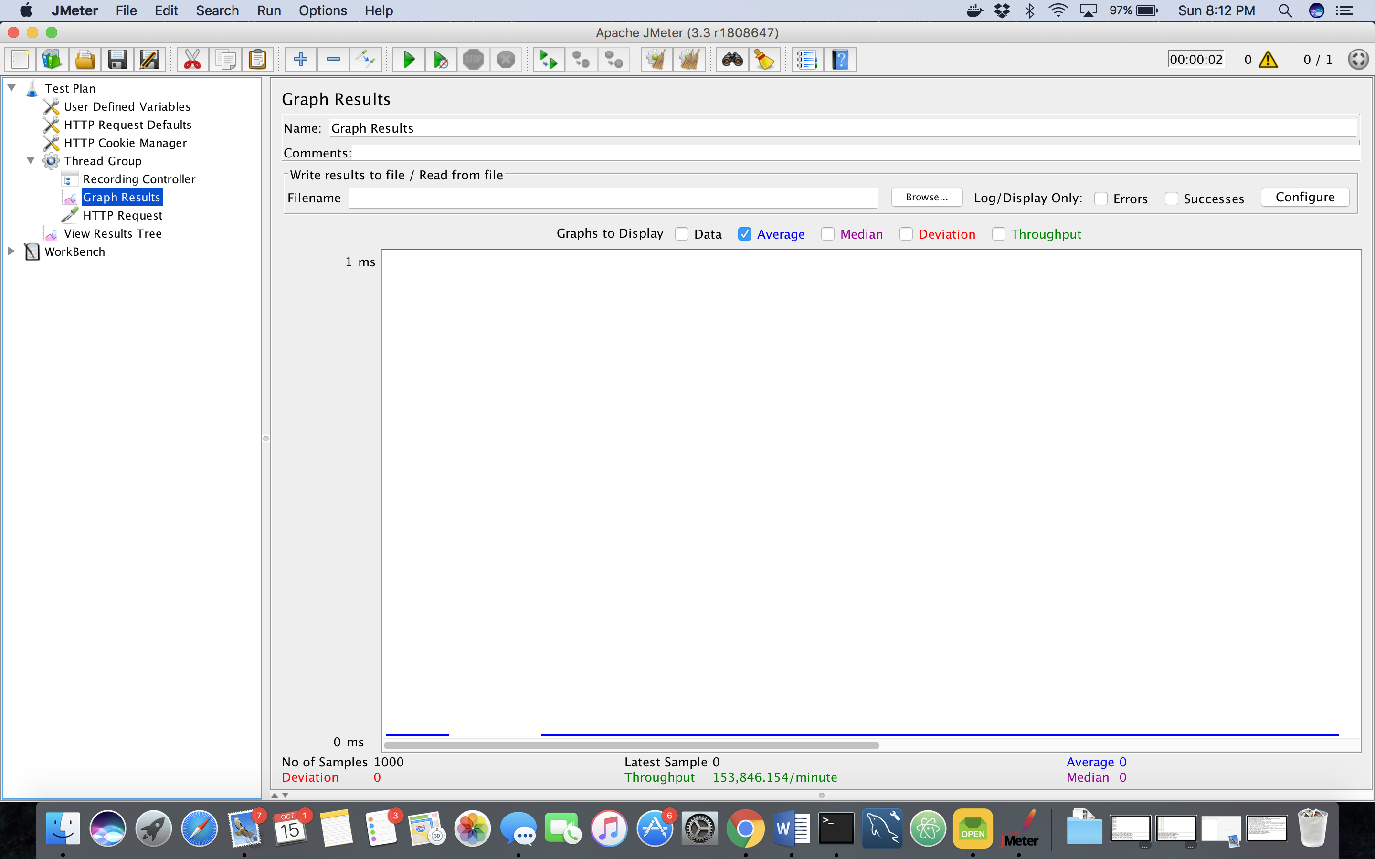

**When 5000 calls are made:**

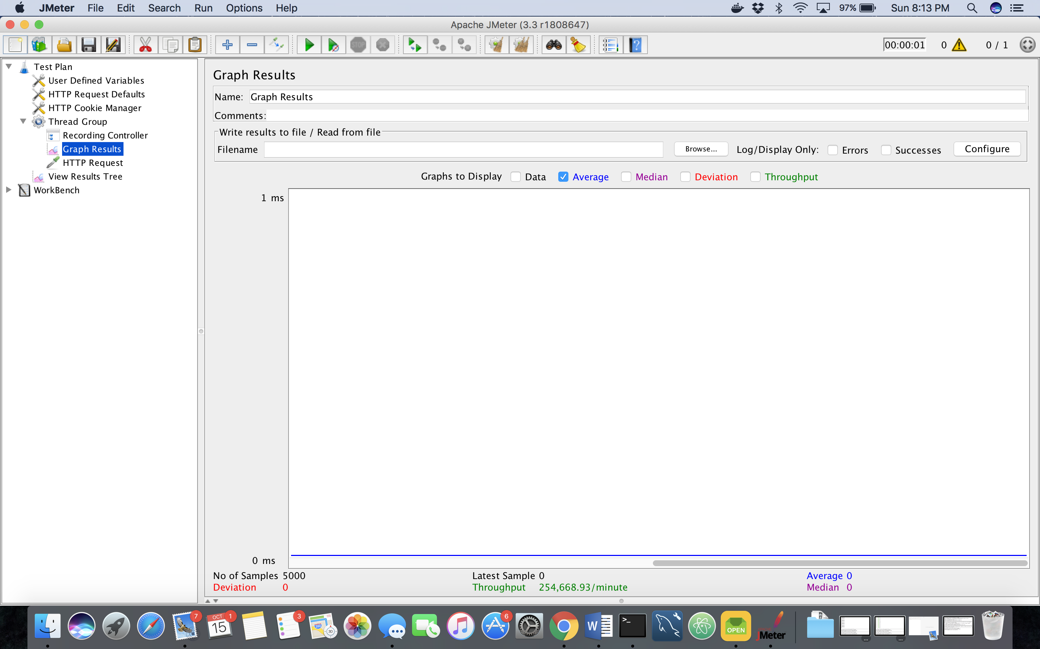

**When 1000 calls by 100 random users are made:**

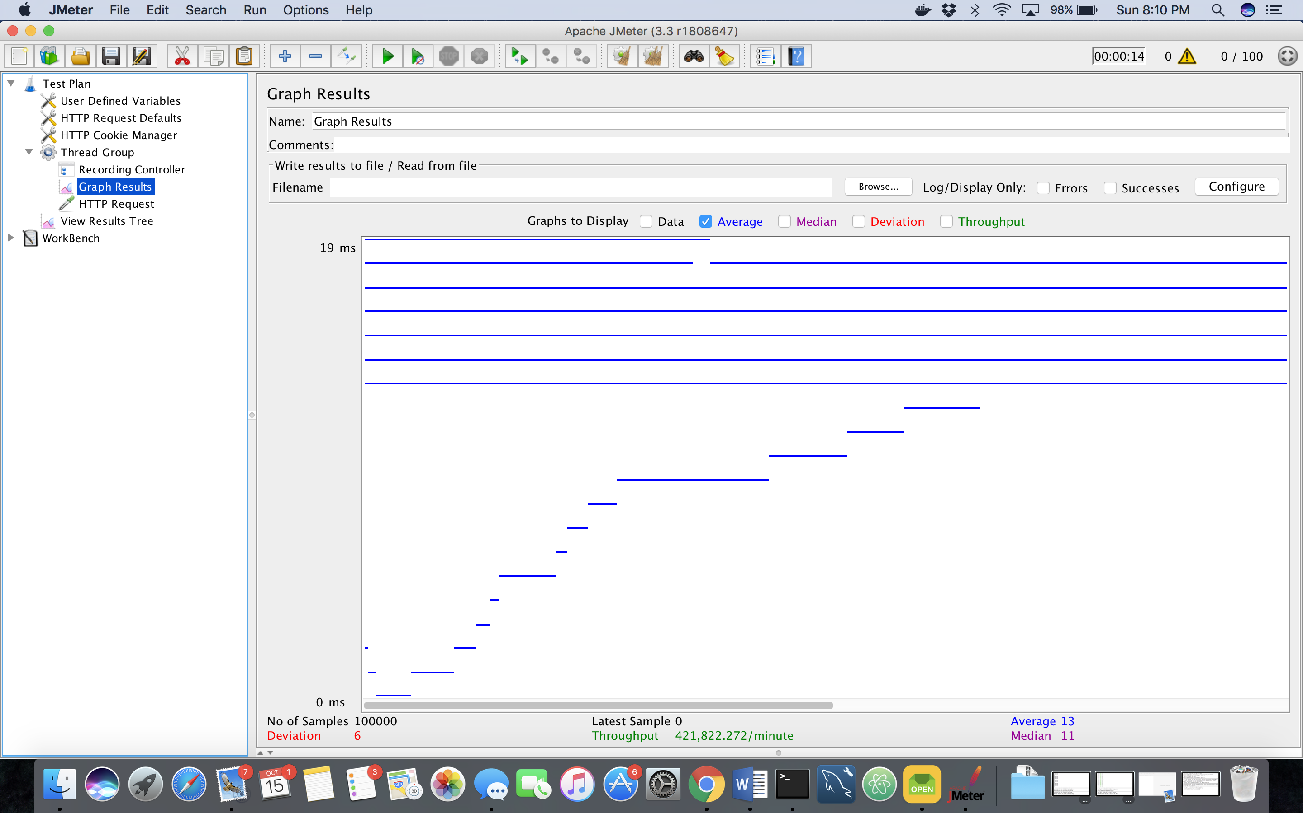

**SUBTRACTION:**

**When 1000 calls are made**:

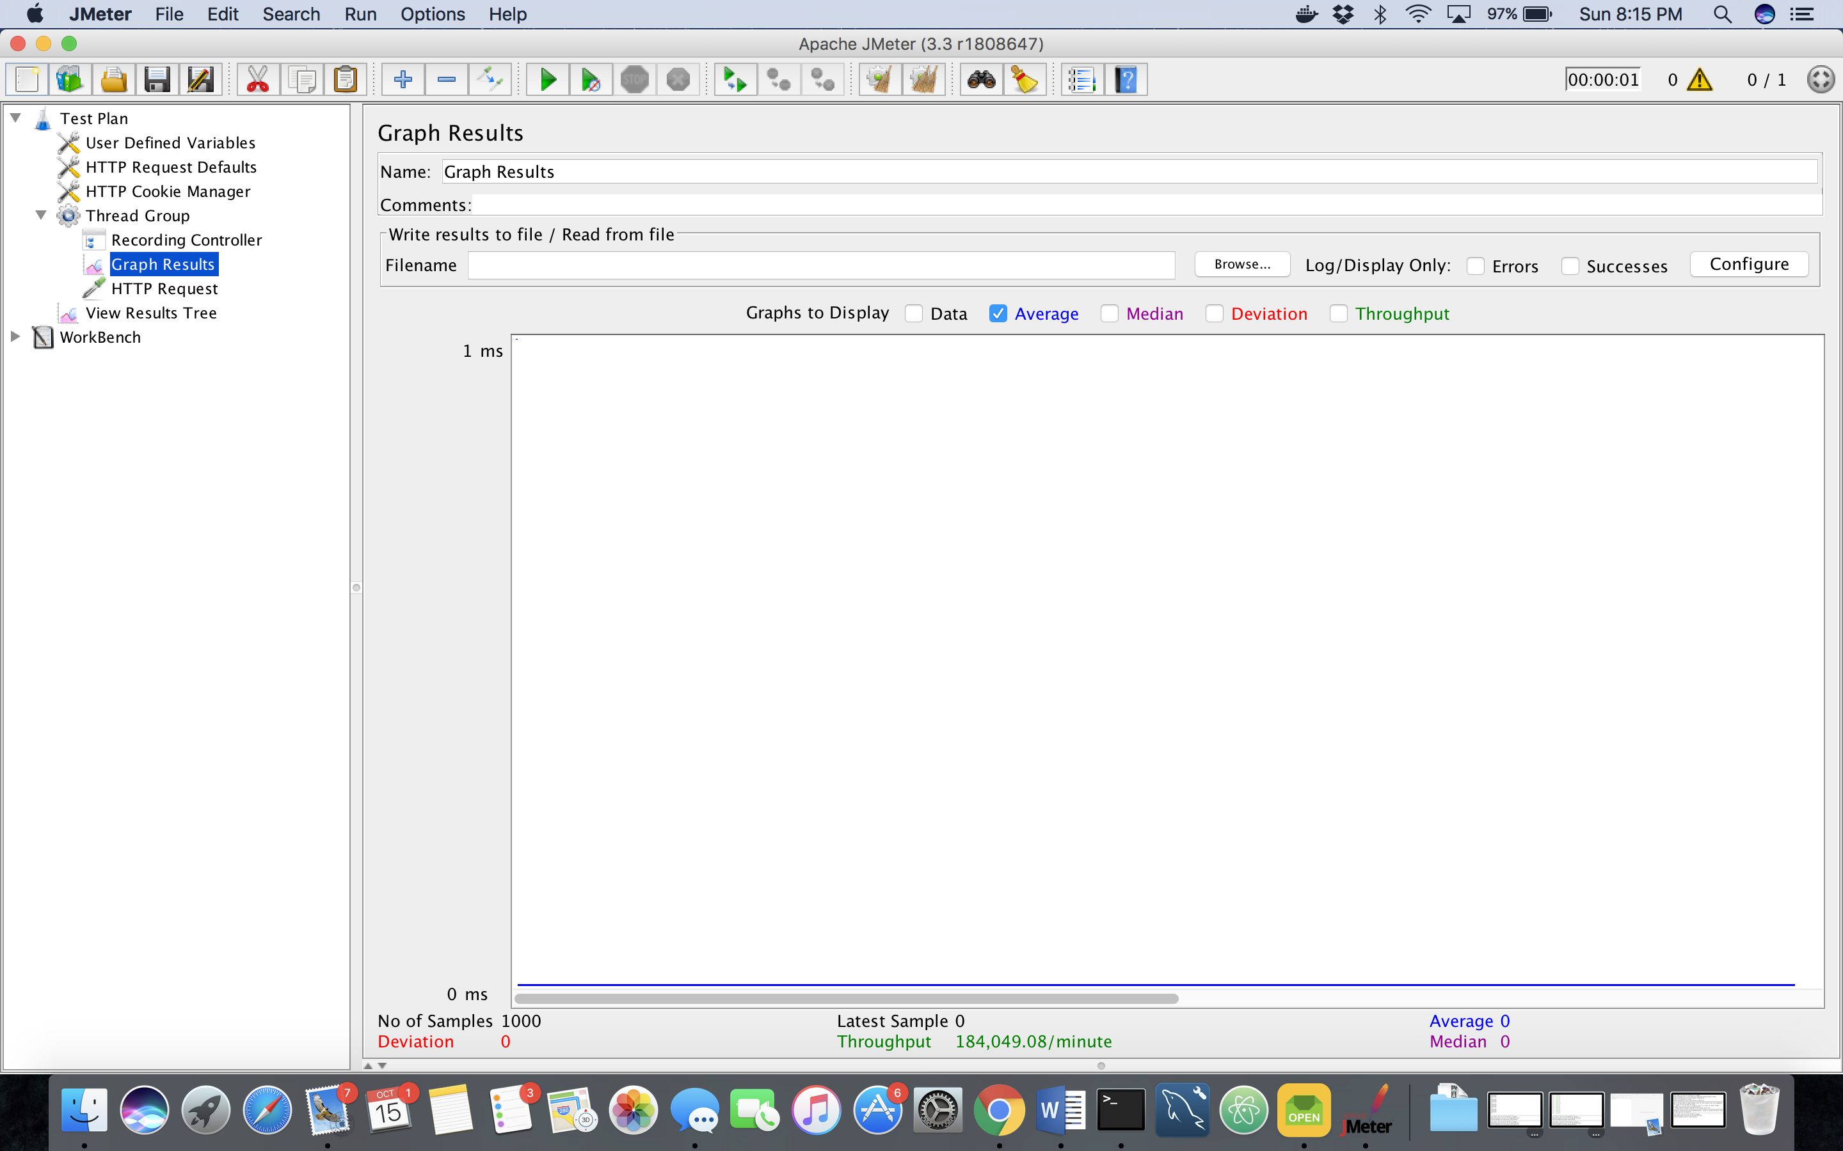

**When 5000 calls are made:**

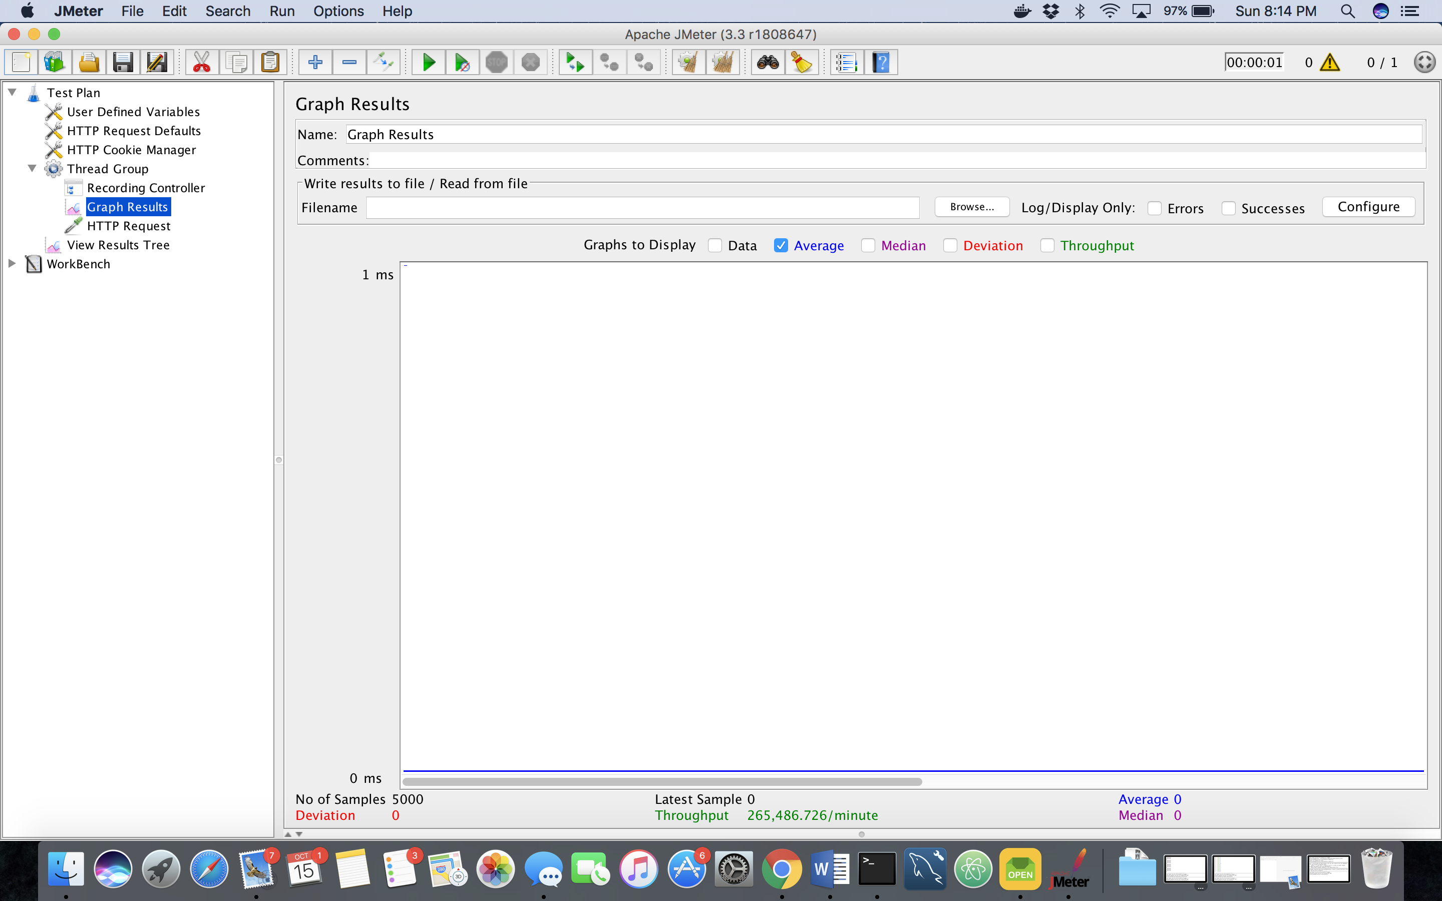

**When 1000 calls by 100 random users are made:**

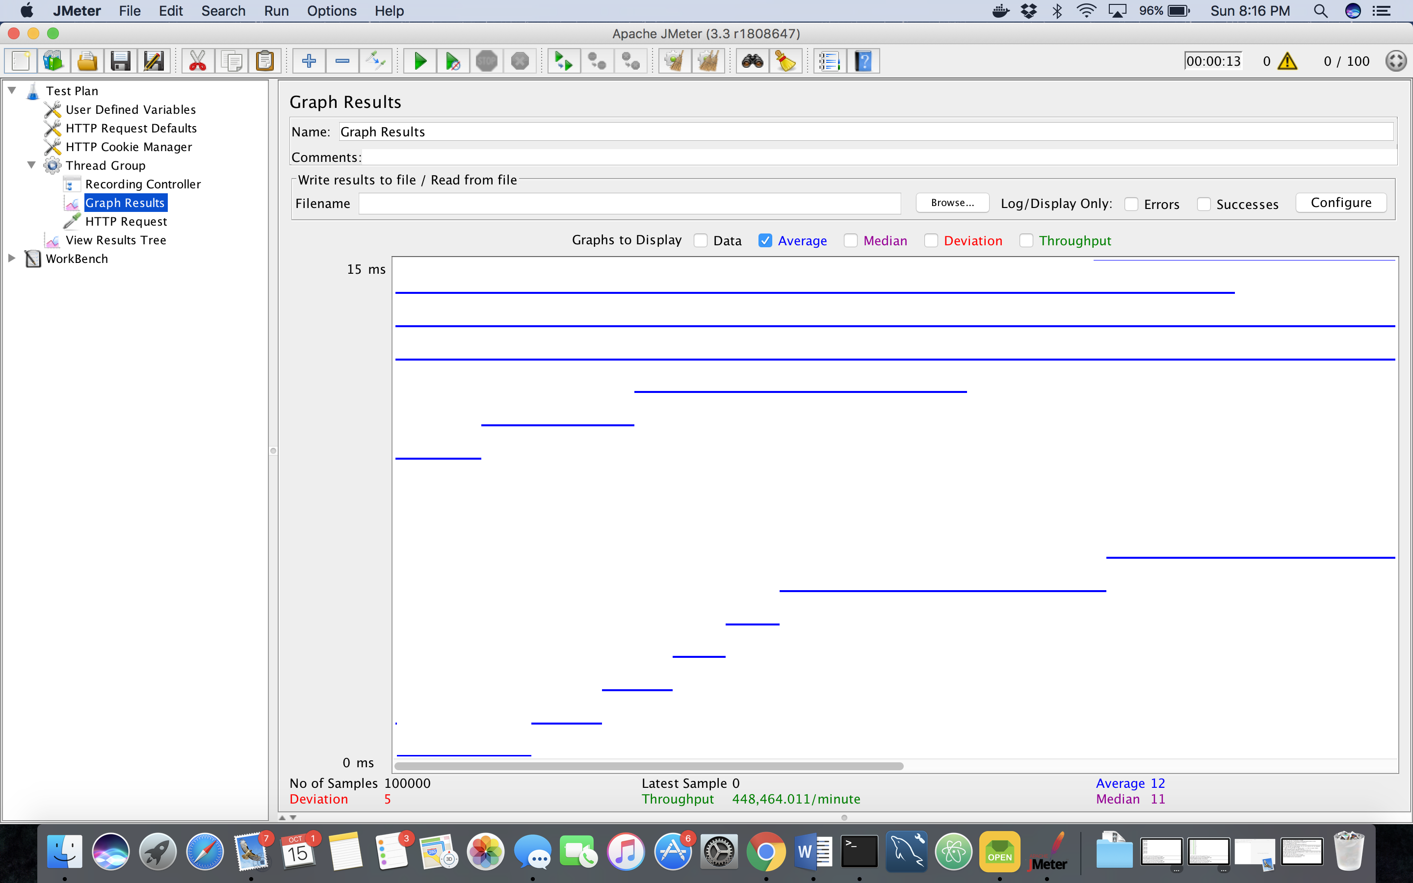

**MULTIPLICATION:**

**When 1000 calls are made:**

**(CONTD)**

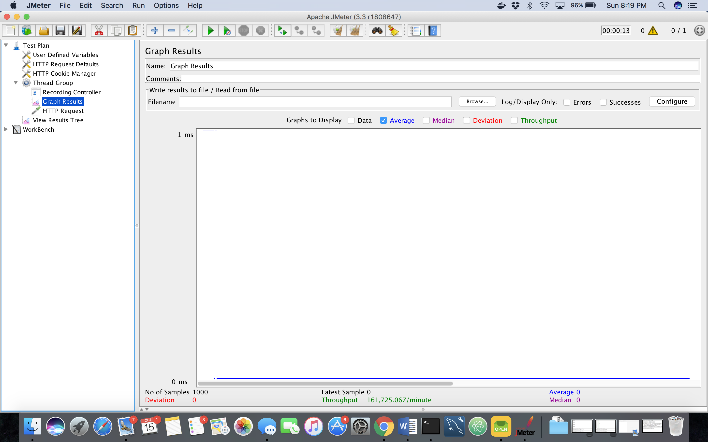

**When 5000 calls are made:**

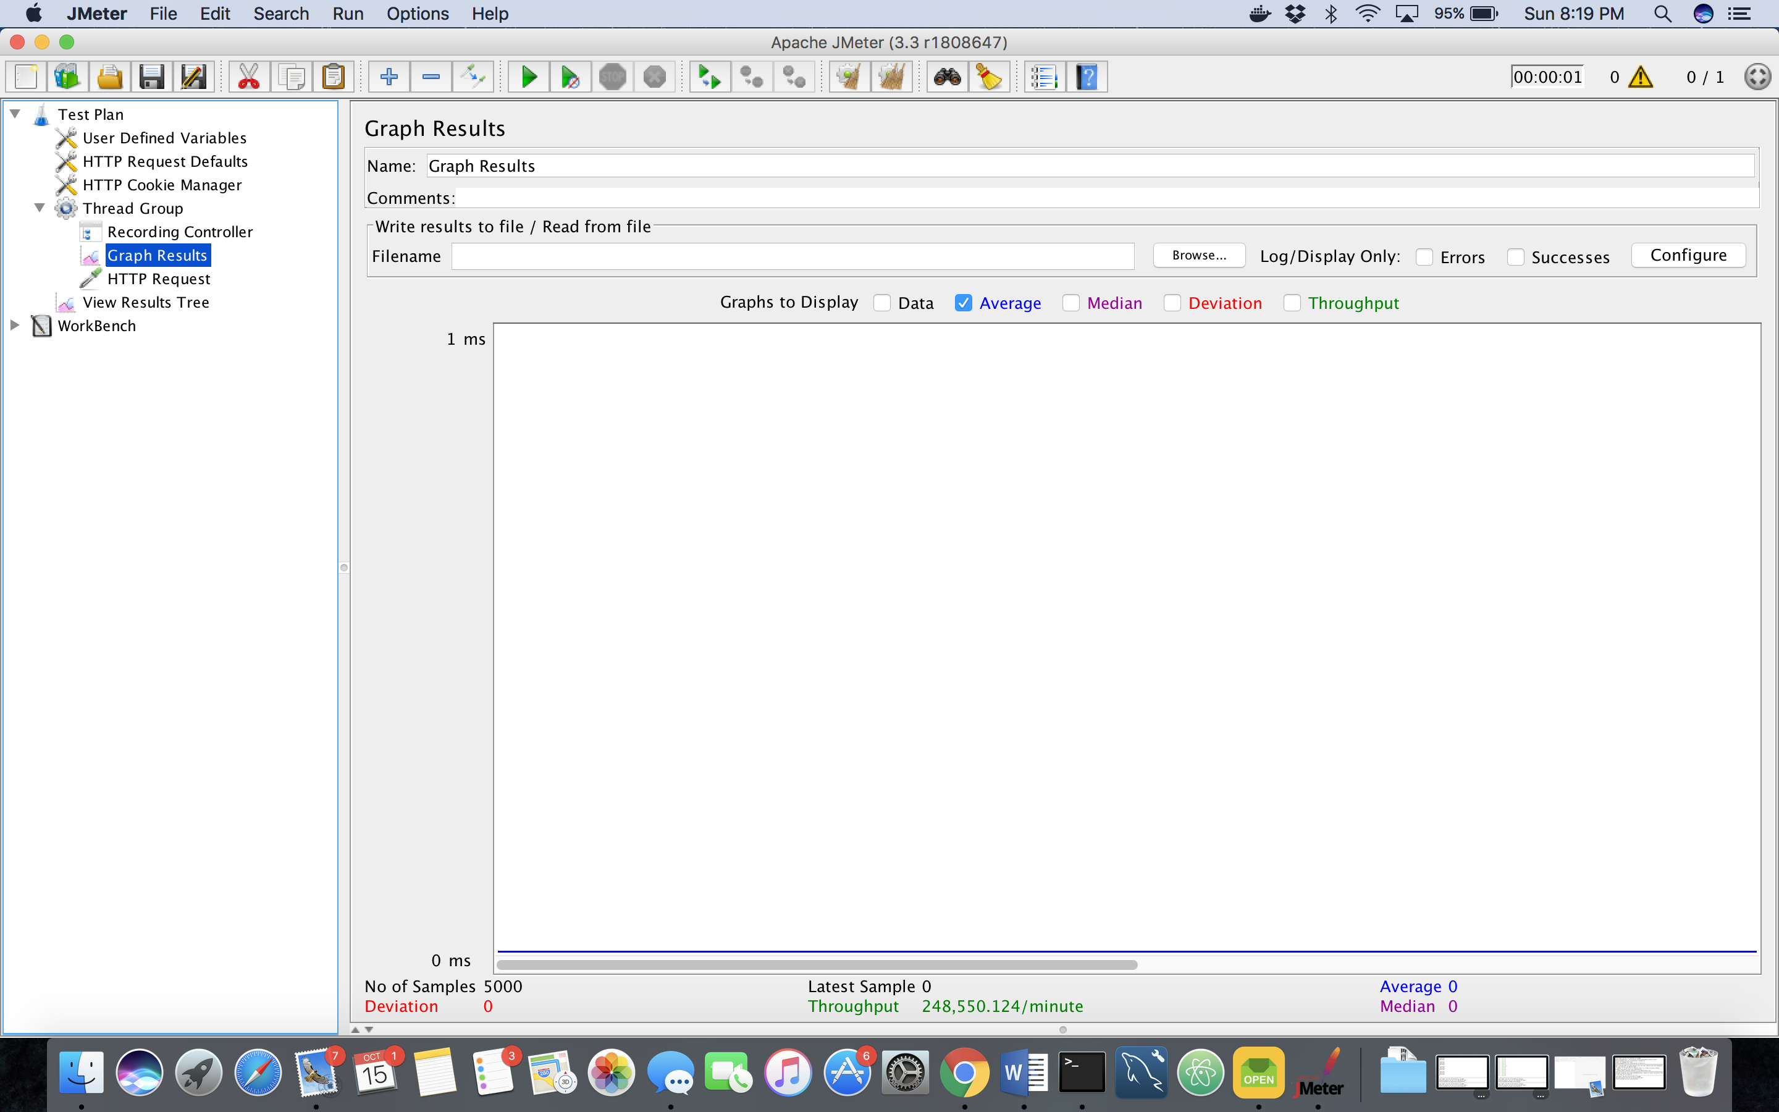

**When 1000 calls by 100 random users are made:**

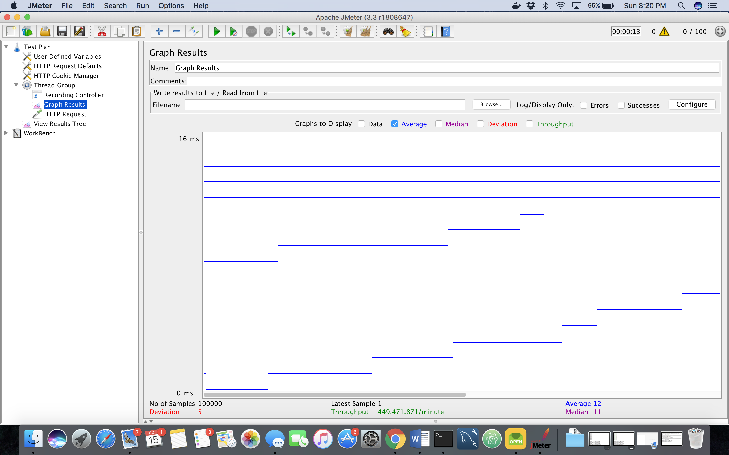

**DIVISION:**

**When 1000 calls are made:**

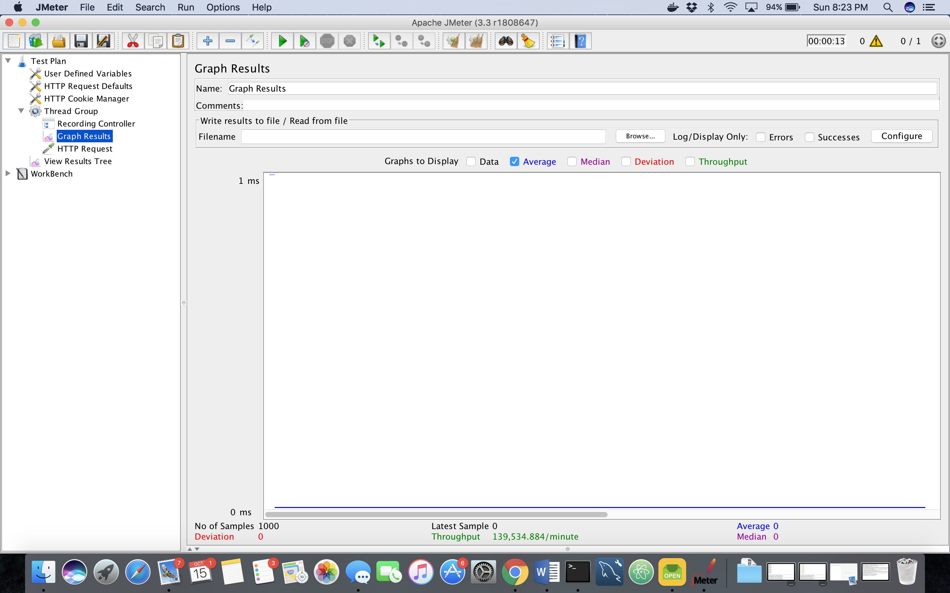

**When 5000 calls are made:**

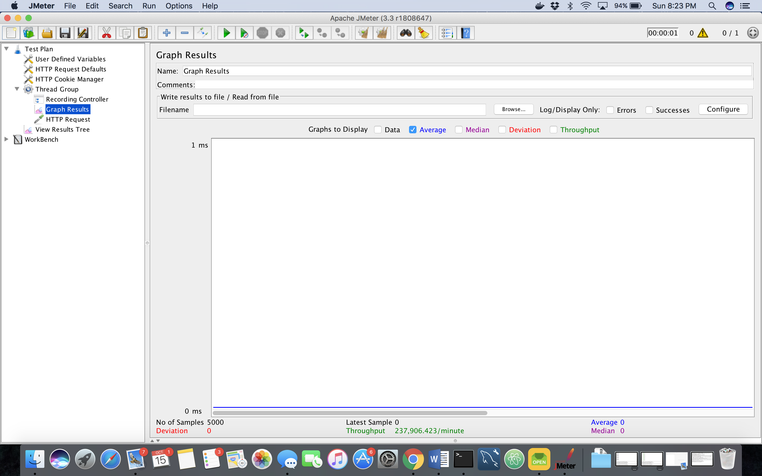

**When 1000 calls by 100 random users are made:**

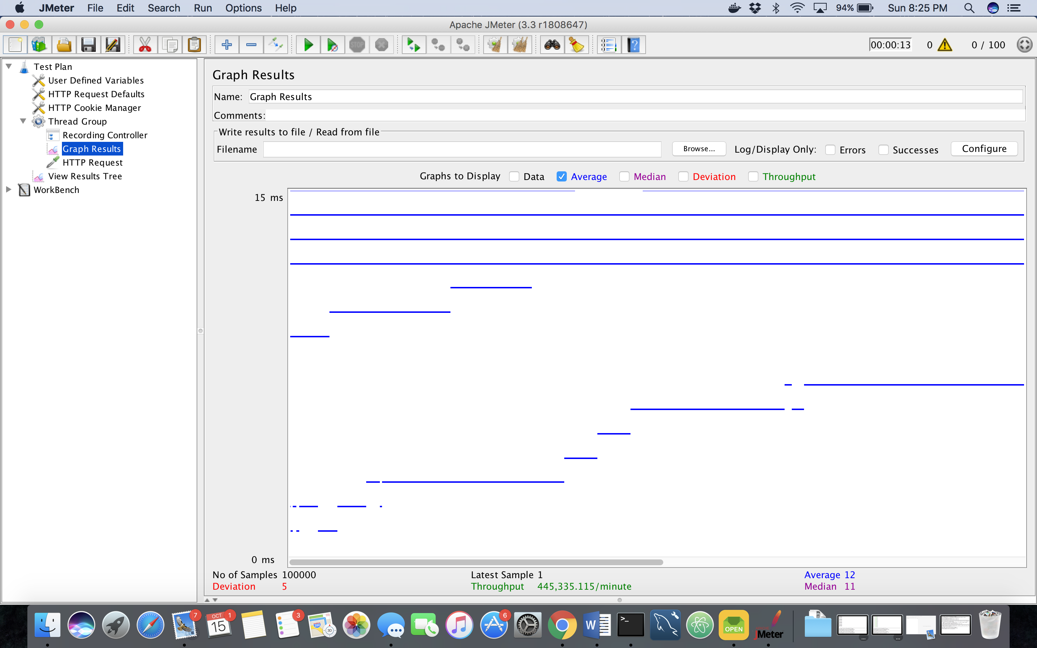

**Analysis of Graphs:**

* The average time for each operation for 1000 and 5000 concurrent users comes out to be zero and the graph is a straight line.
* Though for 100 concurrent users making 1000 concurrent calls randomly, the average time for addition is slightly different from the other operations.
* While multiplication, subtraction and division has the same average time of 12 ms, addition takes 13ms which is fractionally higher than the others.
* Also, the throughput /minute in 3rd case is least for addition which is 421,822.272 while others are close to 448,000.000.
* The performance is similar to server one which was also giving similar average times.

1. **DROPBOX:**

**LOGIN PAGE-**

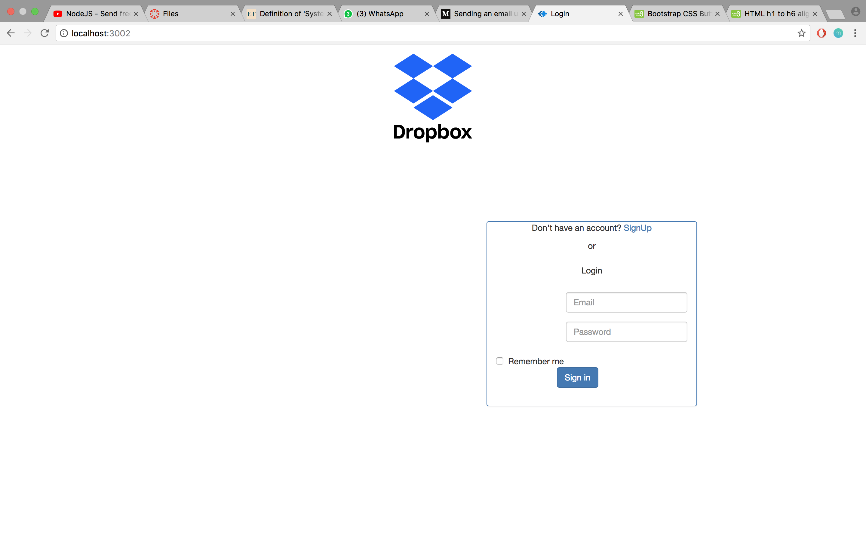

**SIGN UP PAGE-**

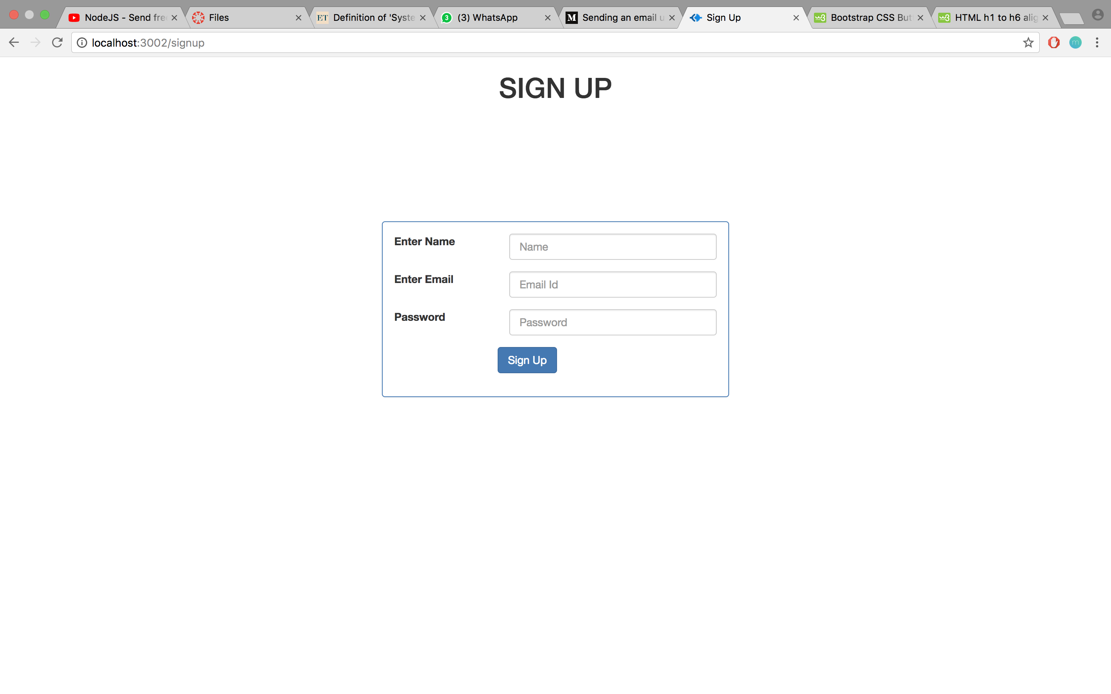

**HOME PAGE-**

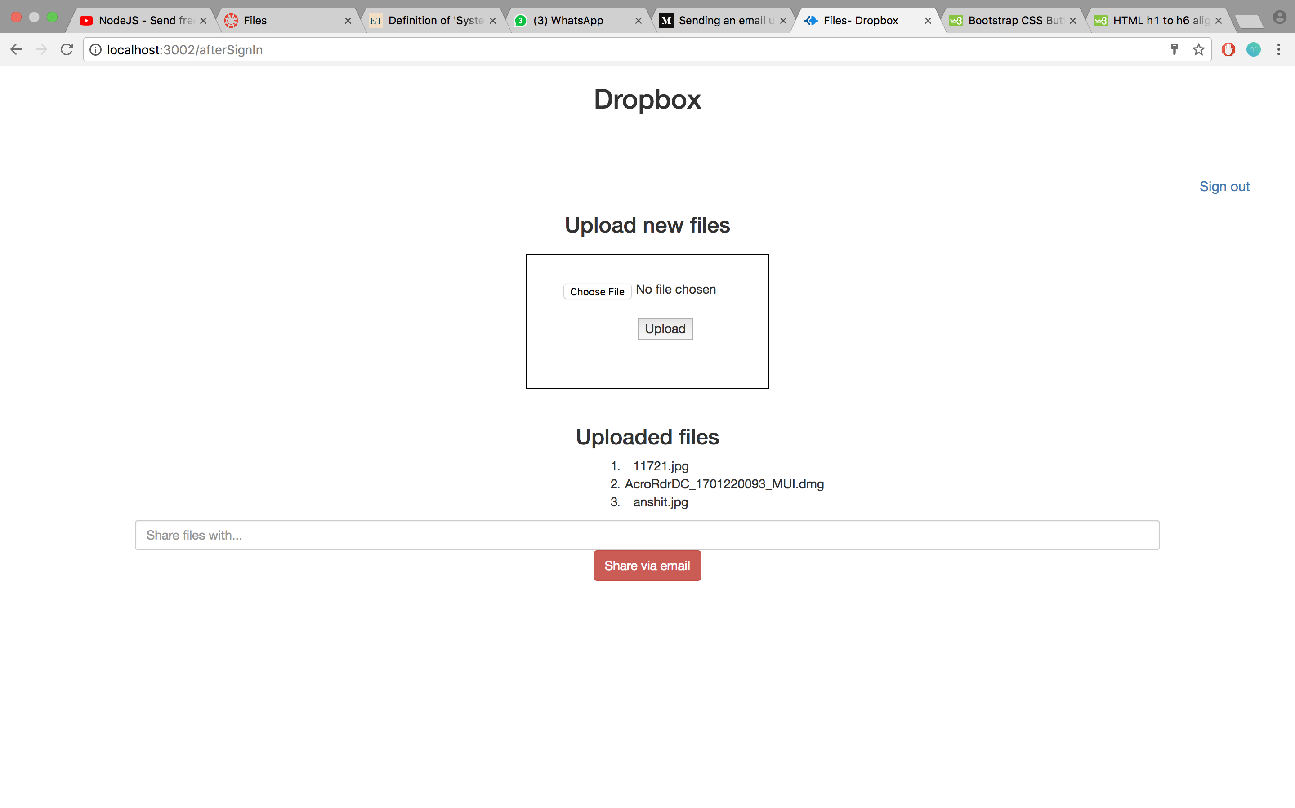

**UPLOADING FILES FROM SYSTEM-**

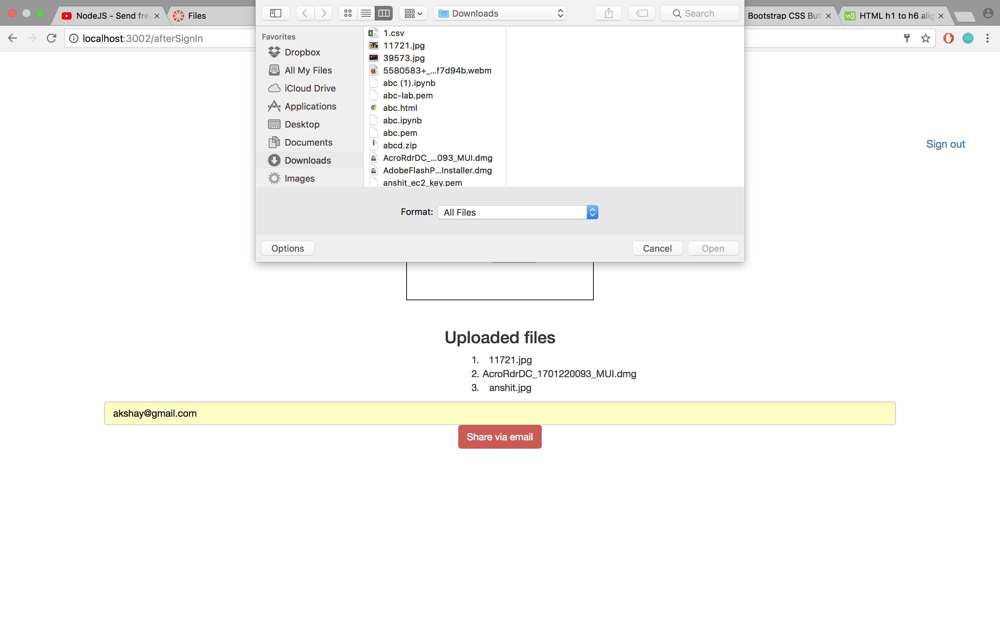

**PERFORMANCE OF THE SYSTEM:**

**Calculator-**

* The performance of the calculator is very consistent throughout for each operation in different scenarios, that is, the average time for all the operations is more or less same in different calls by different users.
* This may be because all the four operations (+,-,*,/) are very similar to one another and none of them creates too much system overhead and hence the average time is very fast and similar to each other.
* Though, the average time of addition was found to be slightly higher but that was fractional and still was nothing too different from others.

**Dropbox-**

* This application due to connection pooling improves the average time as it creates cached connections and other users can use the same connection later.
* Bcrypt function allows password encryption which saves the users’ password from being hacked and makes the system secure.
* Also, the server is stateless that means that the user information is on the browser and not on the server which means it can be scaled out and hence making it better for use.
* The dropbox application allows you to:

**Sign up**

**Sign in**

**Sign out**

**Upload files**

**See file listing of a user**

**Share folder via email**

The functionalities implemented in backend include:

**Connection pooling**

**Password encryption**

**Question:**

Compare the results of the graph with and without connection pooling of database. Explain the result in detail and describe the connection pooling algorithm used in your code.

**Answer:**

Graphs with and without connection pooling of 100, 200, 300, 400 and 500 concurrent users are shown below:

**100 users:**

With pooling:

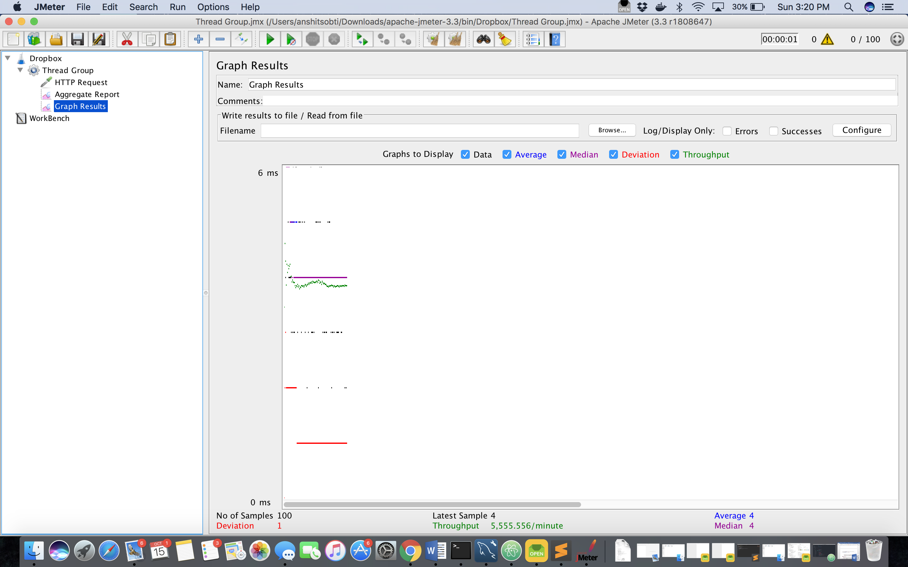

Without pooling:

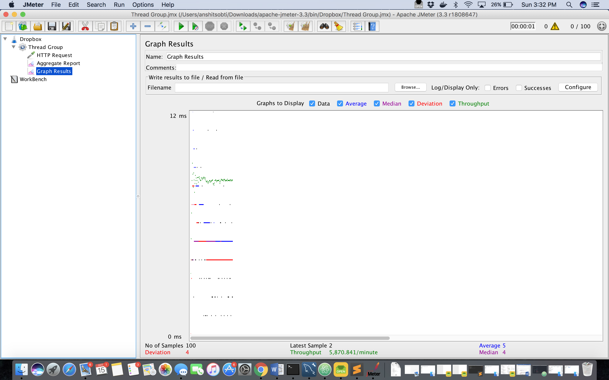

**200 users:**

With pooling:

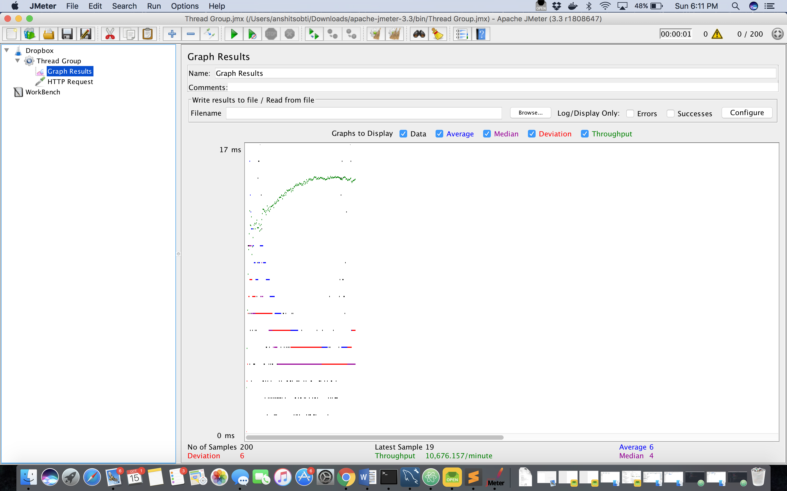

Without pooling:

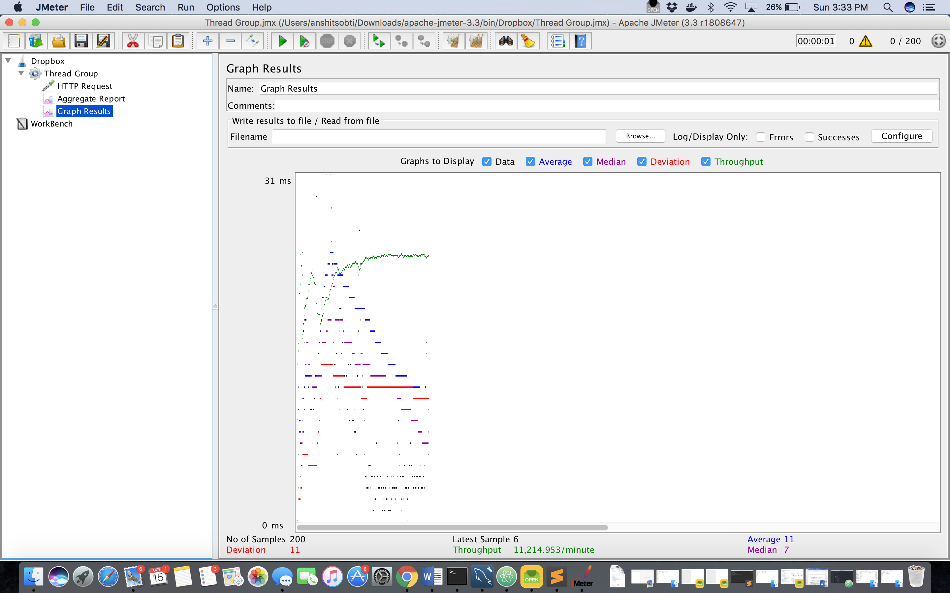

**300 users:** (With pooling)

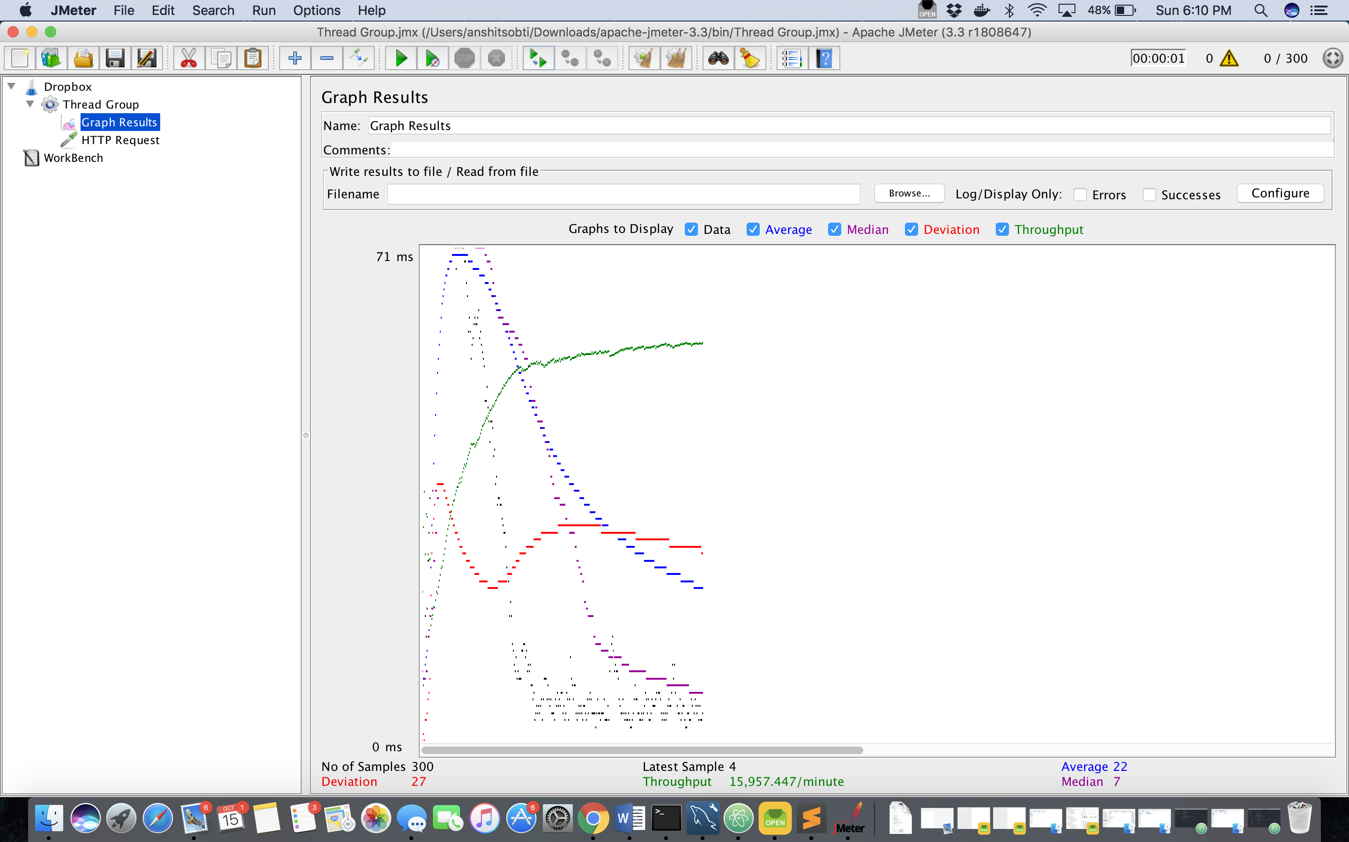

Without pooling:

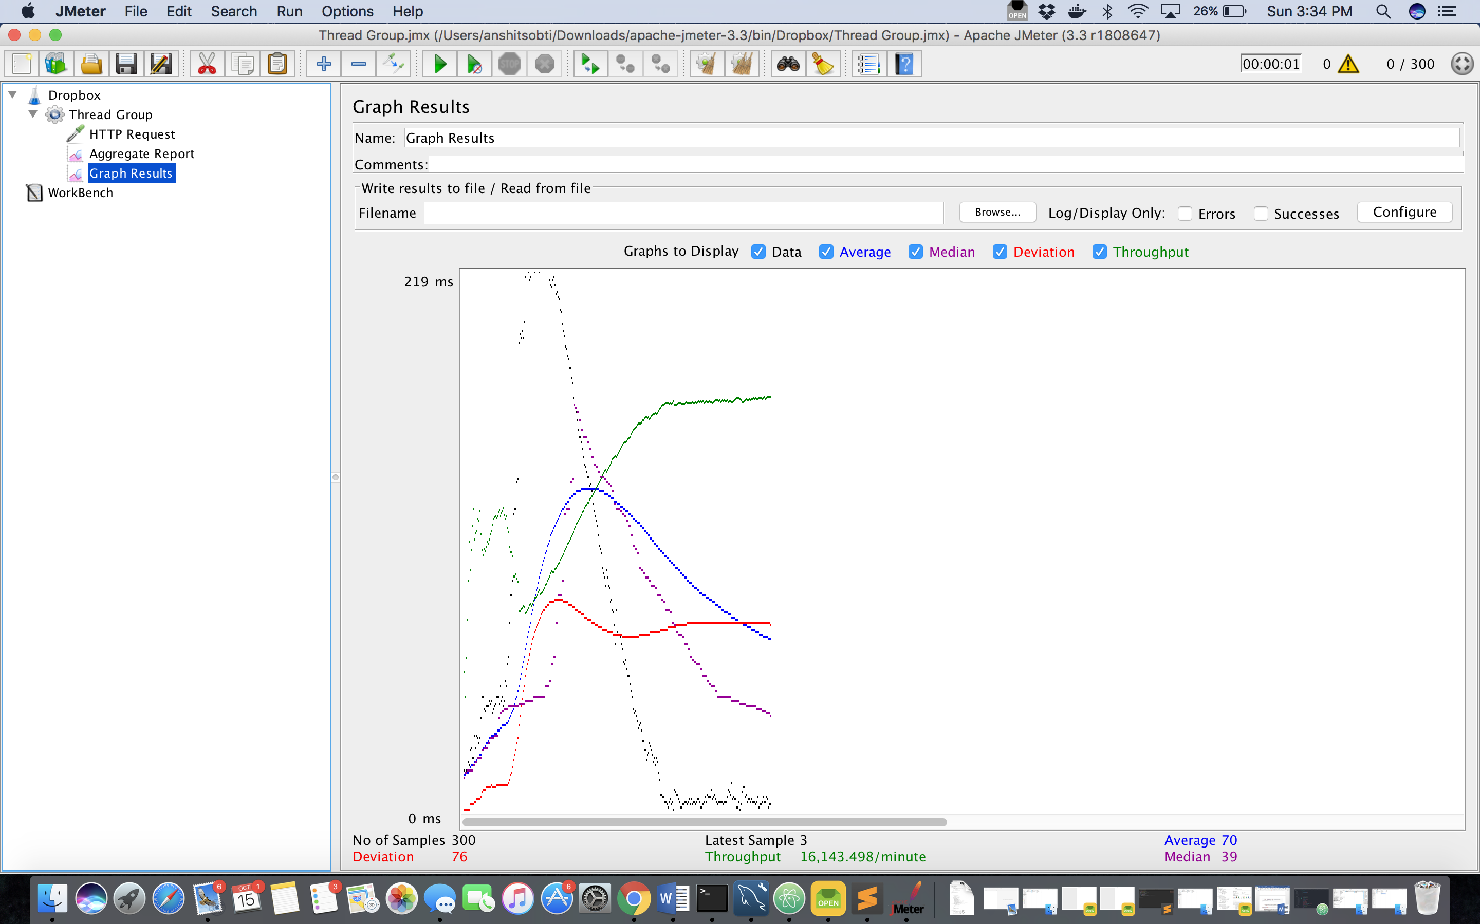

**400 users:** (With pooling)

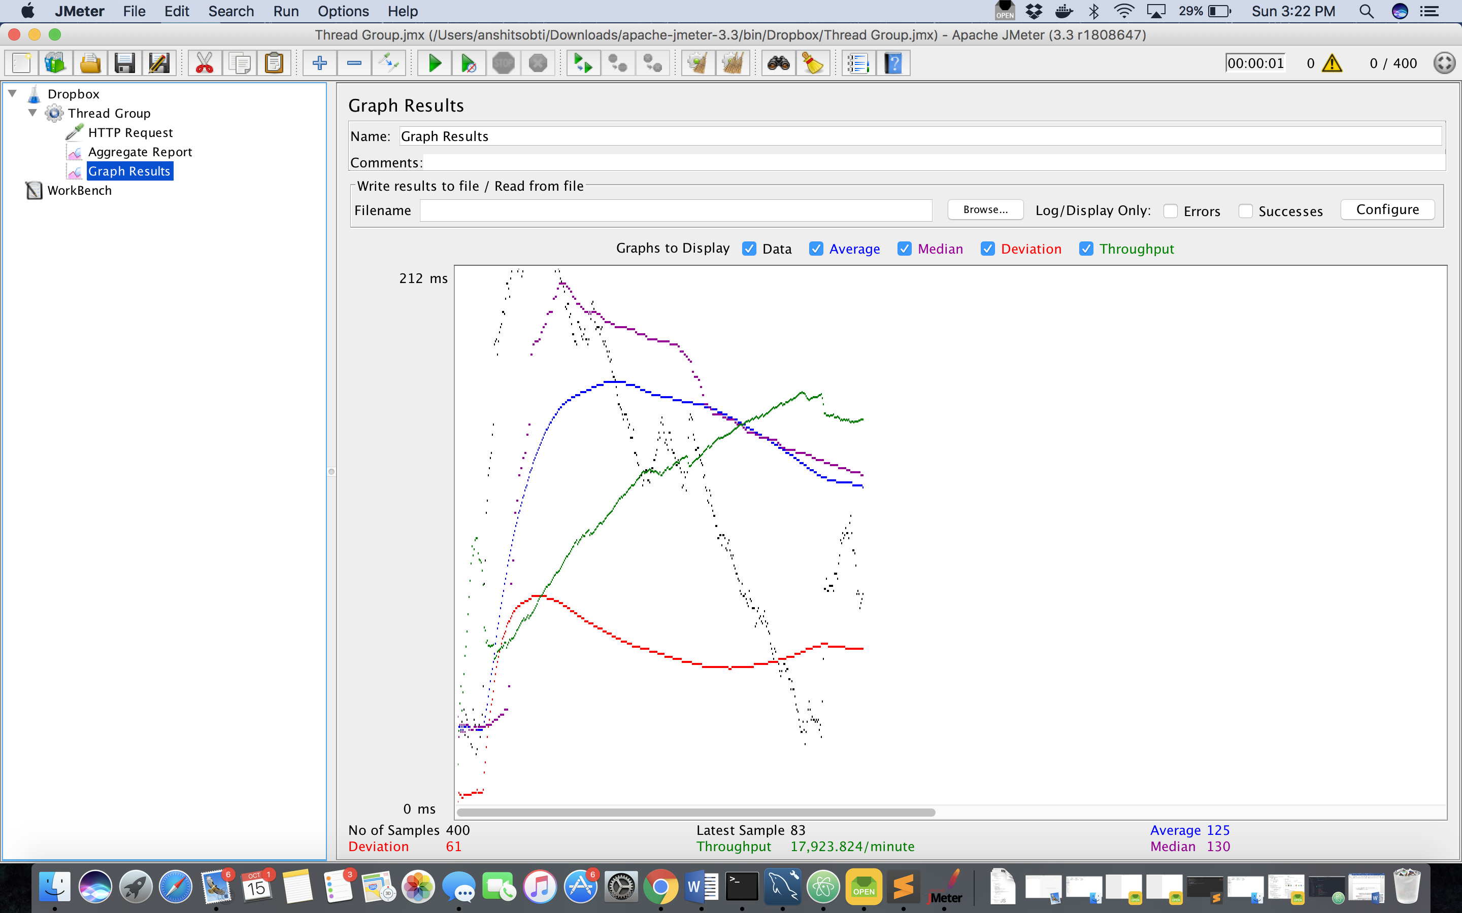

Without pooling:

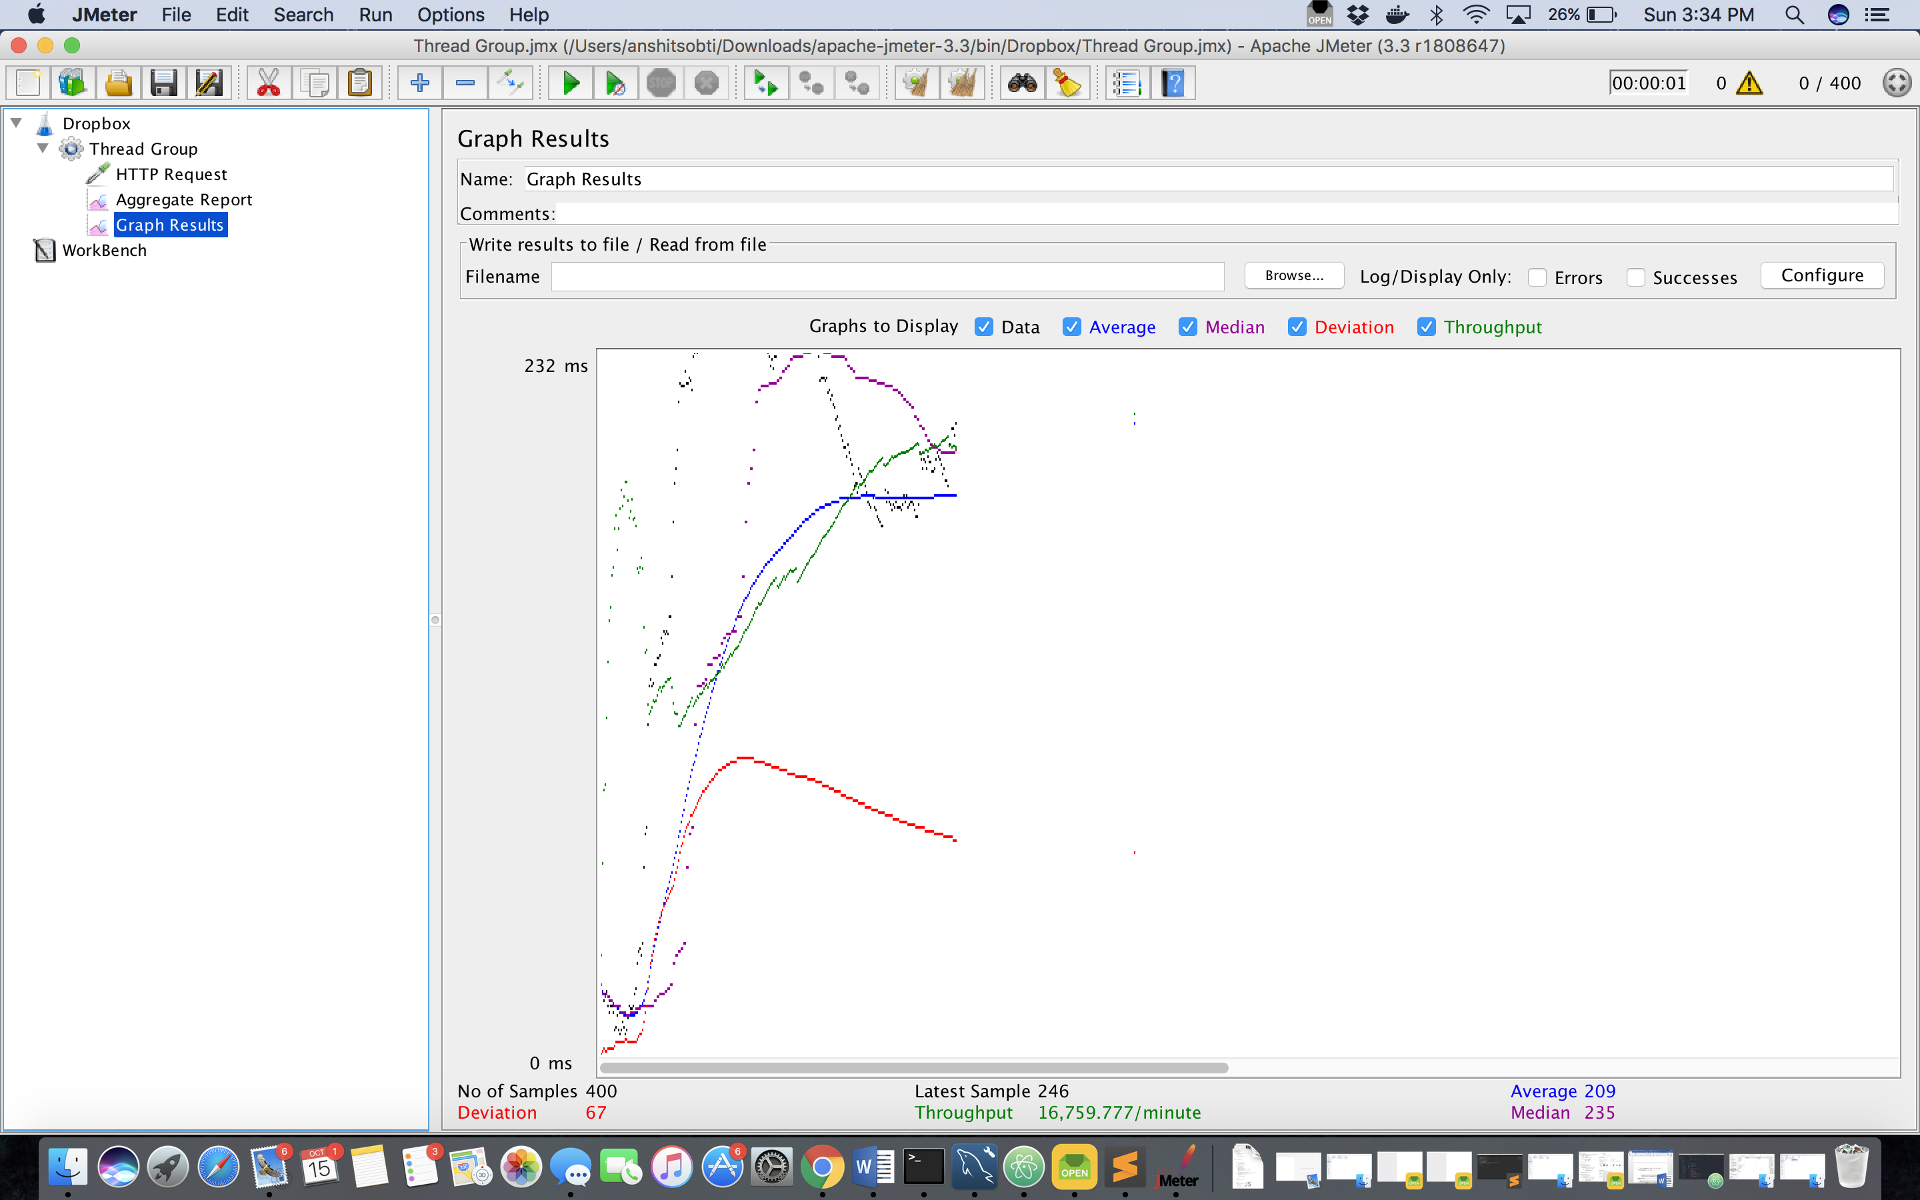

**500 users:** (With pooling)

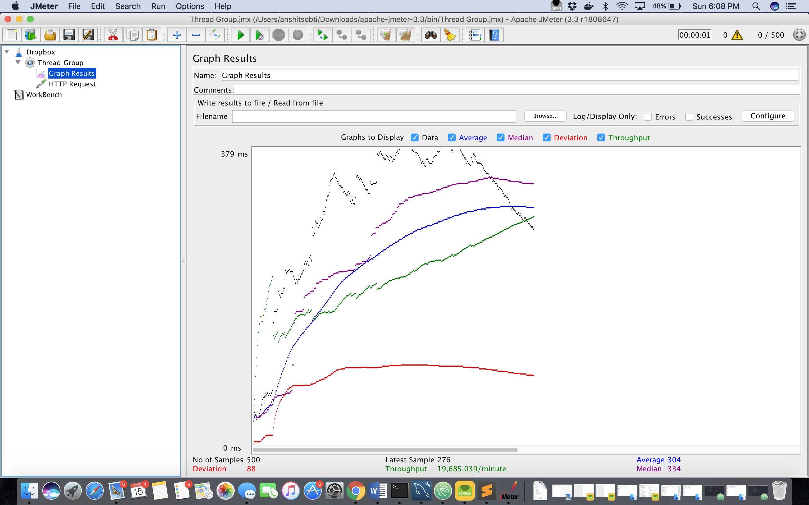

Without pooling:

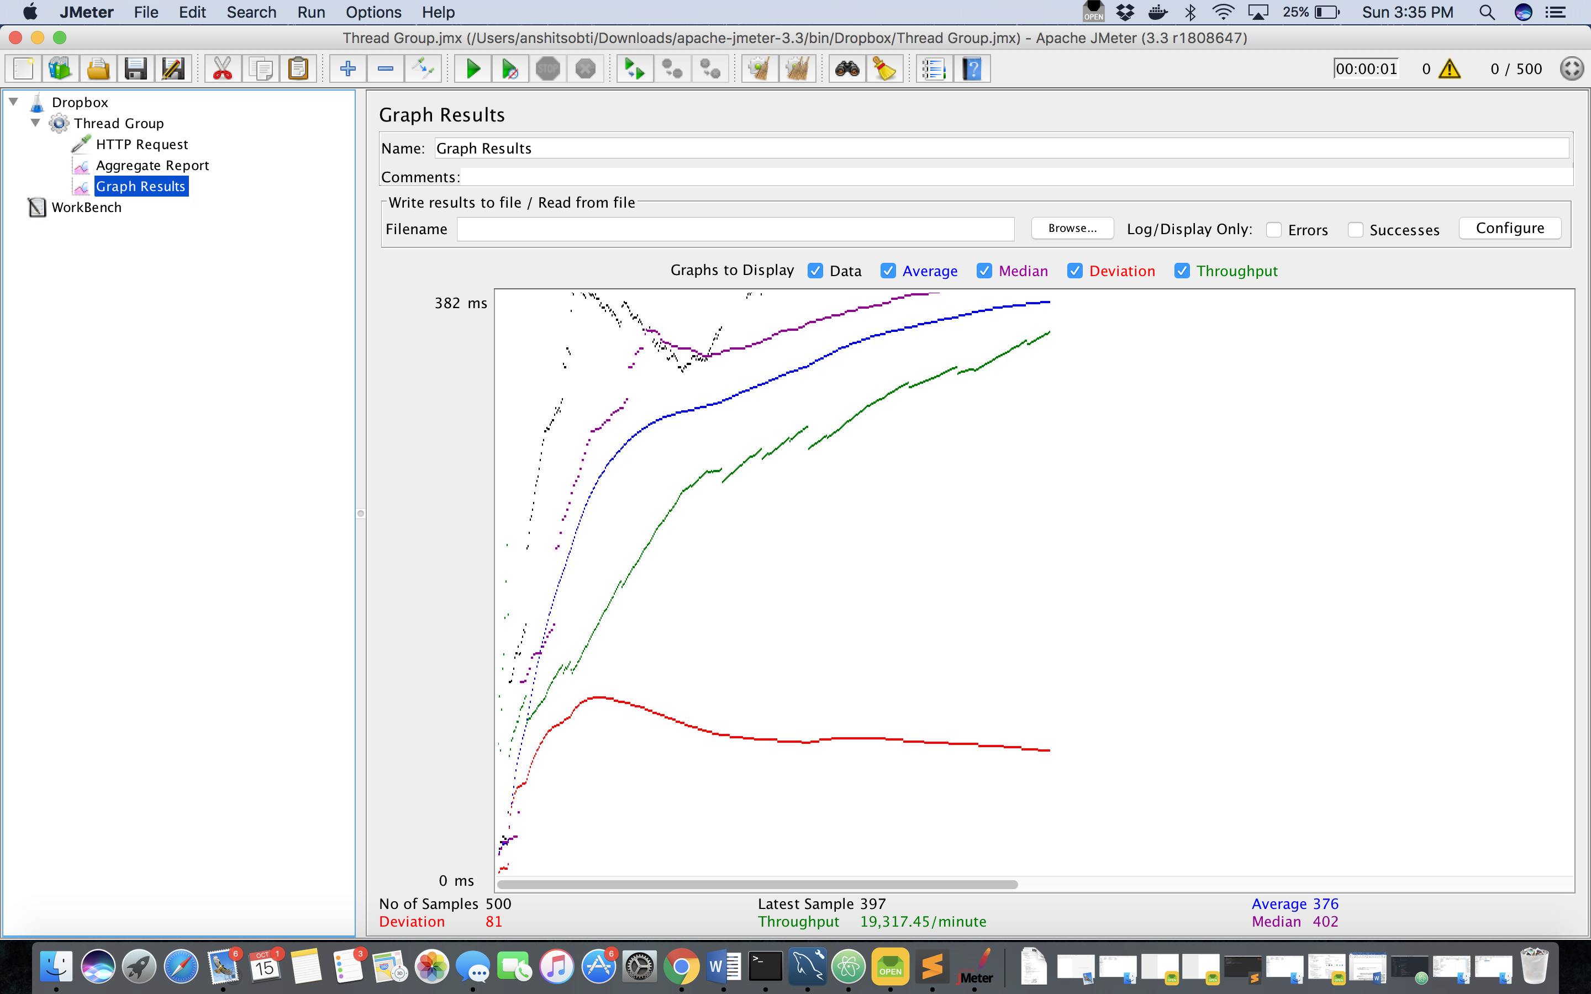

The above graphs show how the average time of the system is affected when 100, 200, 300, 400 and 500 concurrent users are using it. In all the cases, the average time of the system with connection pooling is always less than that without connection pooling.

This is because in case of connection pooling, cached connections are formed which can be then used by the users coming later which saves the time to make a connection again, hence reducing the average time of the system.

One more conclusion that can be made from the above graphs are that the performance of system gets better due to connection pooling when the number of users are increase, so as the number of users increase the connection pooling comes into use.

The connection pooling used in my application consists of two simple bucket stacks, when a connection is requested it is popped from the free stack and after the connection is used, it is pushed back onto the free stack. The other stack has used connections and initially all of them are in free stack.

**Question:**

What is SQL caching? What type of SQL caching is available and which suits your code the most. Write a pseudo code or explain in detail.

**Answer:**

SQL caching is a process where data is stored (cached) on some front-end devices which makes the data access pretty convenient and fast. The backend database will not be used everytime as it may not be available due to lose of connection.

Types of SQL caching:

1. Adhoc Query Caching
2. Autoparametrization
3. Forced Parametrization
4. Prepared Queries

**Adhoc Query Caching**-

In this type of caching, the cached block is used only if a subsequent batch matches textually in the exact same manner. To take advantage of adhoc queries not only same data values or queries are to be used, but both the lines should be completely same. Even a difference of a single space will make it take both the queries as separate queries.

**Autoparametrization**-

In this type of caching, if two or more queries use a similar structure then they can be used as the same plan. For example, if we write two queries which are as follows:

Select name, age from students where rno = 12;

Select name, age from students where rno = 32;

Since its basically the same query where only the roll number (rno) changes, both will be saved as adhoc objtypes while there will be one more row that will have ‘Prepared’ as the objtype and this plan will be used twice.

Though, autoparametrization is done very carefully by the SQL server and only those queries are chosen whose plan will not change even if the actual parameters change or who will return only one value and those are known as safe.

**Forced Parametrization**-

It is an alternative to autoparametrization that is provided by SQL server to force parametrization on a query if is not auto parametrized as the server consider it to be safe. Forced parametrization can be enabled by:

ALTER DATABASE <database_name> SET PARAMETERIZATION FORCED;

The data type in auto parametrization is assumed by the server on its own which can only be controlled by forced parametrization.

**Prepared queries**-

It refers to prepared plans that the constructs that show up have. Both the constructs allow programmer to decide which values are parameters and the data type used for parameters.

One construct is the SQL server stored procedure sp_executesql and the other construct uses the execute method.

With sp_executesql we do not have any entries of the adhoc query.

I think Forced Parametrization is the type of caching that suits my code the most as I have tables of users’ information and also the file information in mysql database which leads to accessing particular records from the database repeatedly by email id (which is unique) and if that particular command can be cached and parametrization can be forced on the table to save time and speed of the application.

**Question:**

Is your session strategy horizontally scalable? If yes, explain your session handling strategy. If no, then explain how you can achieve it.

**Answer:**

* The session strategy I implemented in my application is horizontally scalable as the session related information is stored on the client side and that session can be passed to many servers at a single time.
* All the servers have a single session to work with and interchange to get better results.
* Here, the application becomes stateless on the server side to improve the performance.
* Though this application is horizontally scalable but it can be further scaled by dividing the app into small but logical and interactive blocks.
* This may lead to cost savings depending on caching and databases.

**References**

* Wikipedia
* [www.w3schools.com](http://www.w3schools.com)
* [www.npmjs.com](http://www.npmjs.com)
* [www.github.com](http://www.github.com) (For reference)
* [www.youtube.com](http://www.youtube.com)
* jmeter.apache.org